

FACULTY OF ELECTRONICS AND COMPUTER TECHNOLOGY AND ENGINEERING

SEM II - 2025/26 BERR 2243
DATABASE AND CLOUD SYSTEM

EXERCISE 3 REPORT

LECTURER NAME:
PROFESOR MADYA DR SOO YEW GUAN

No. | Student Name | Matrix No.
1 | IKMAL IMAN BIN MOHD YUSOF | B122410306
2 | MUHAMMAD ARIF SYAFIE BIN AGUS  SALEH | B022210116
3 | MUHAMMAD HAIKAL BIN ZULKIFLI | B122410348

Step 1
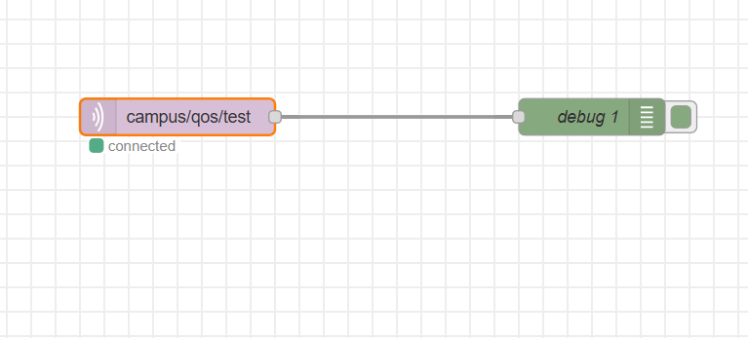
Figure 1: Nodered Connection

Step 2
QoS 0
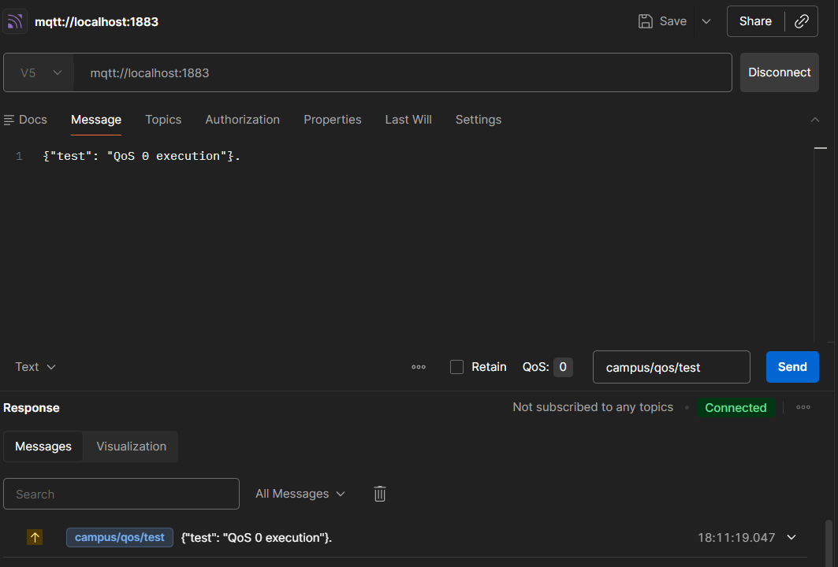
Figure 2 : Postman Configuraton
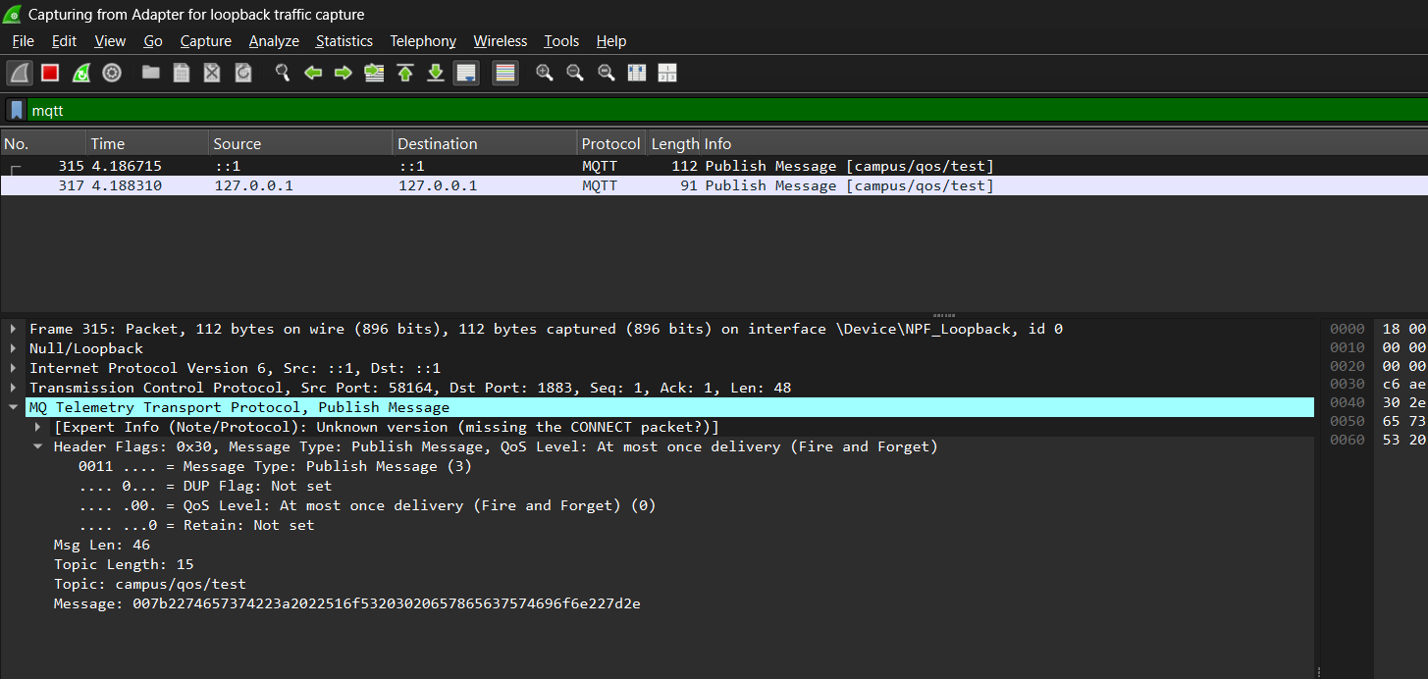
Figure 3: Wireshark Traffick
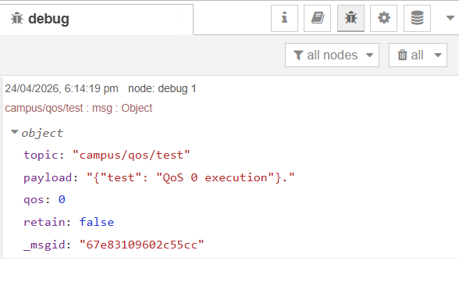
Figure 4 : Nodered Debug input

Step 3:
QoS 1 Execution
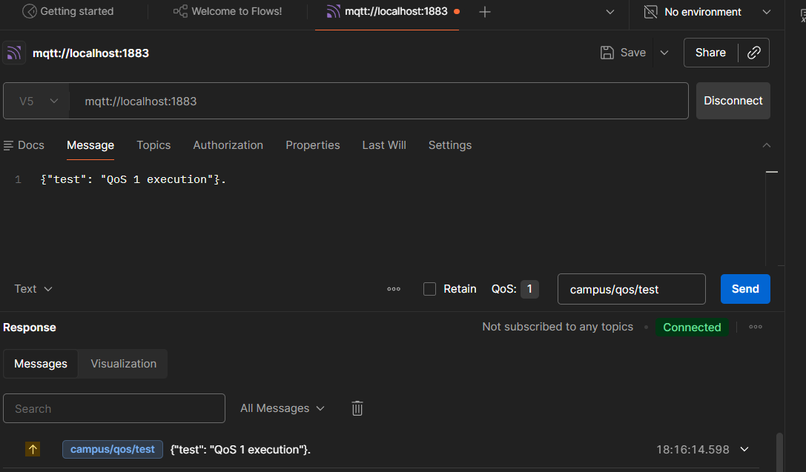
Figure 5 : Postman Configuraton

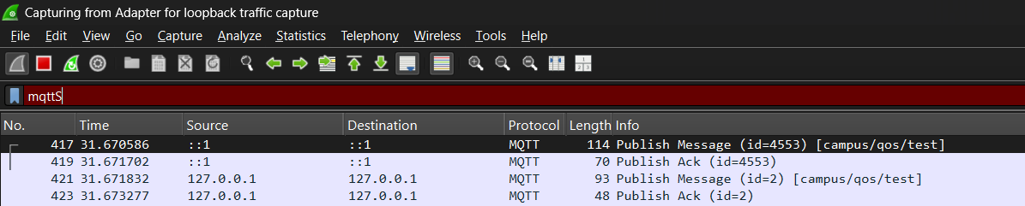
Figure 6: Wireshark traffic
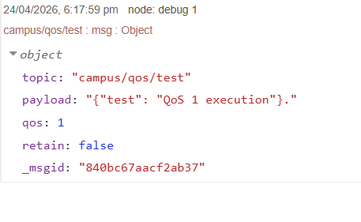
Figure 7: Nodered Debug Output
QoS 2
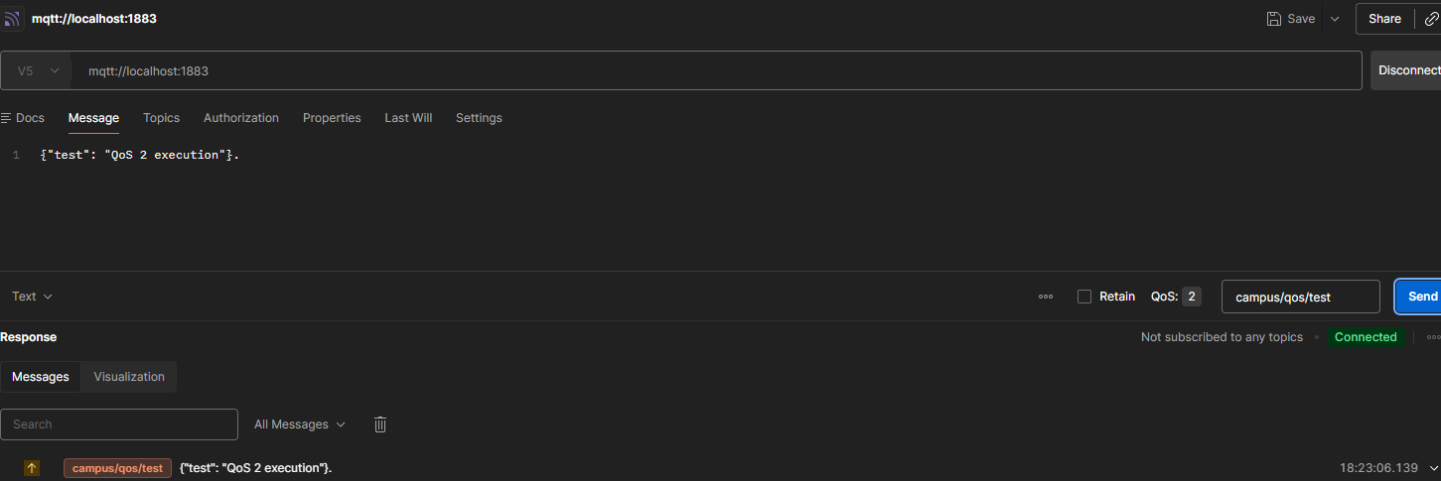
Figure 8: Postman Configuration
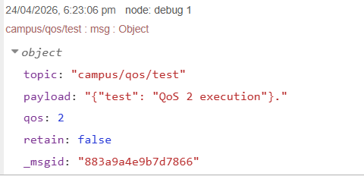
Figure 9: Nodered Debug
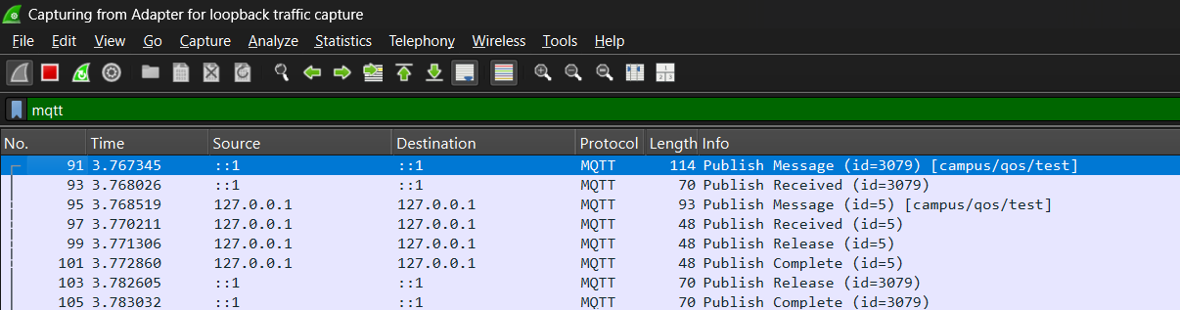
Figure 10: Wireshark Traffic
Step 4: The Retain Flag Mechanism
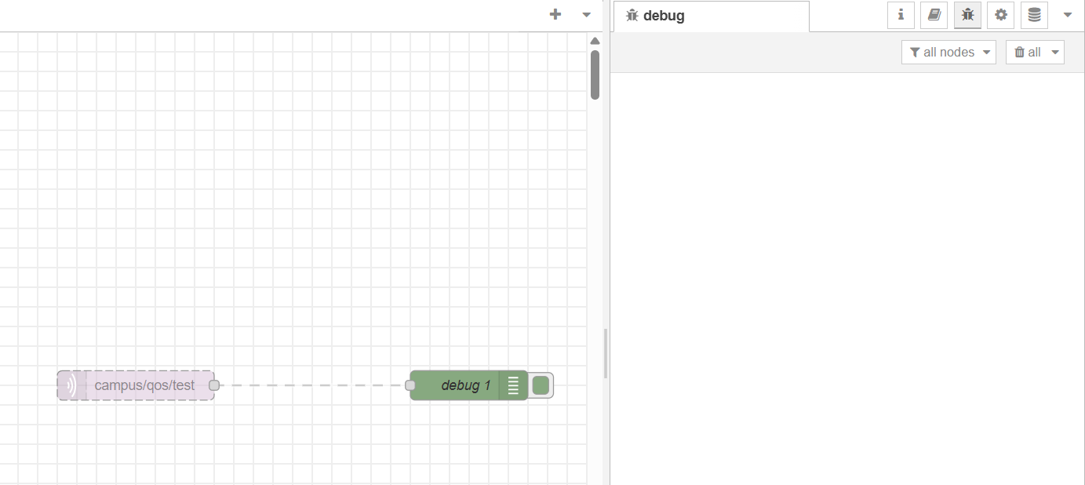
Figure 11: Disconnected the Nodered
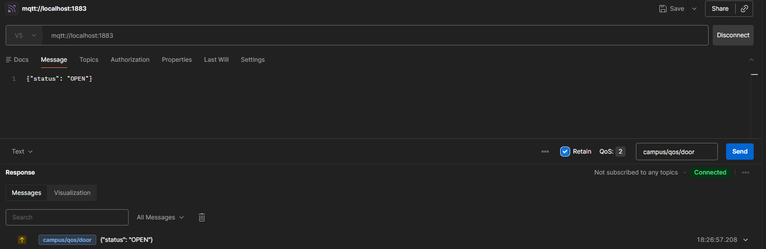
Figure 12: Postman Configuration for
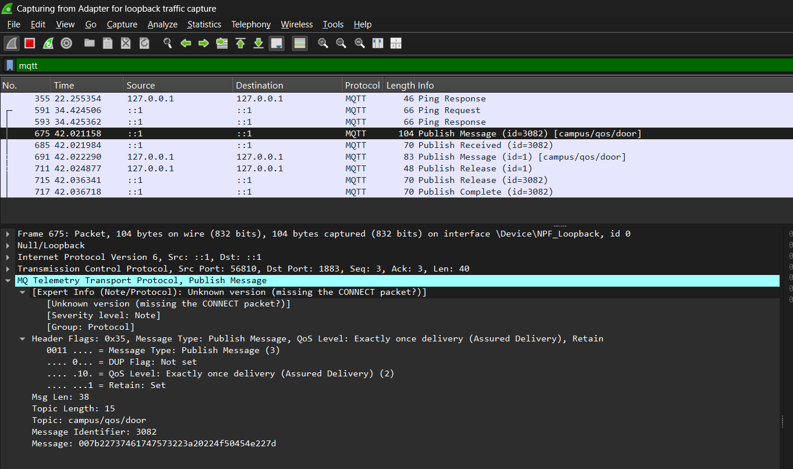
Figure 13: Status of Retain bit
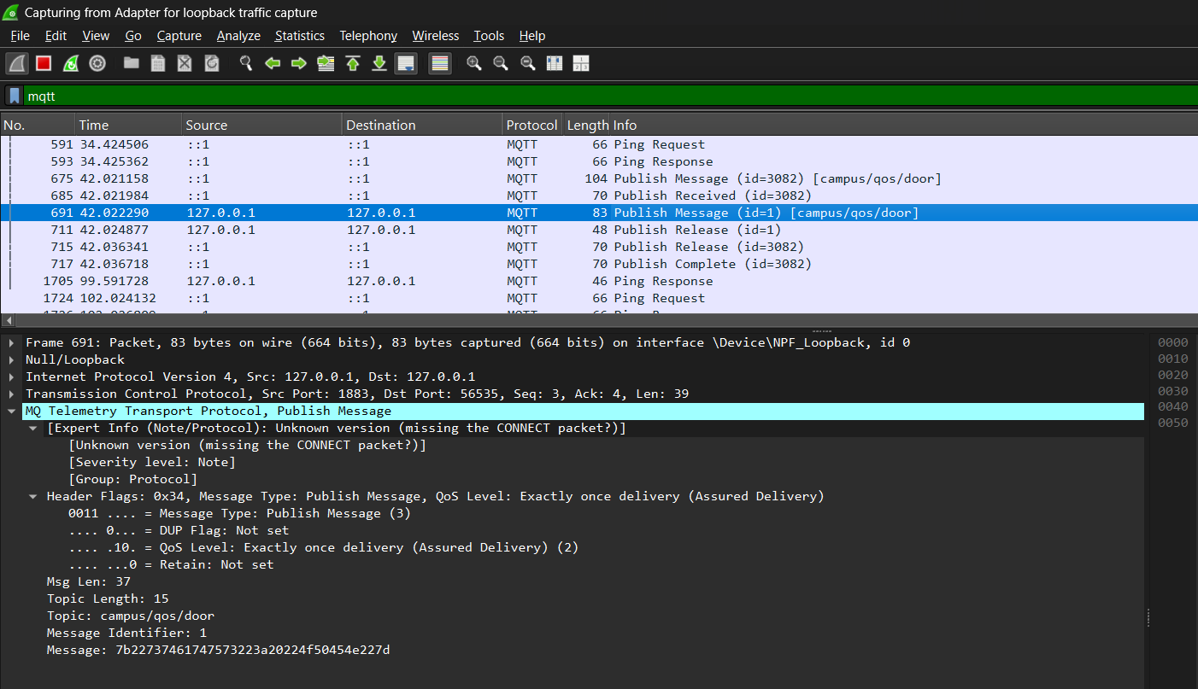
Figure 14: Wireshark Traffic
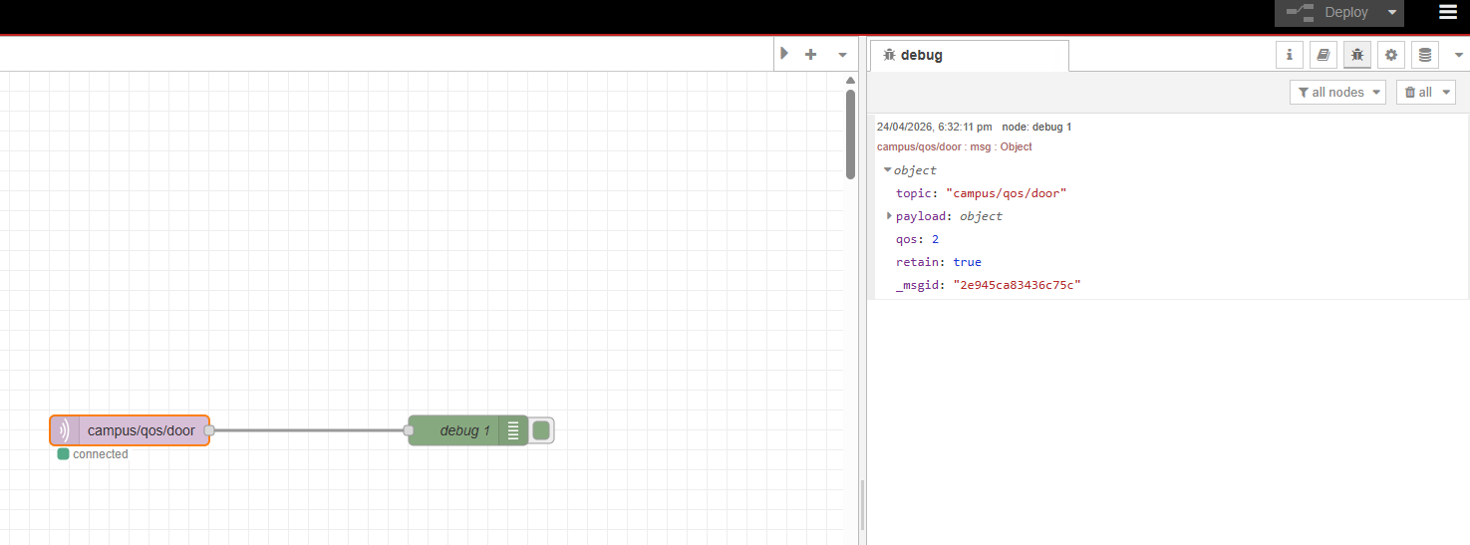
Figure 15: Connect back the Nodered with Debug
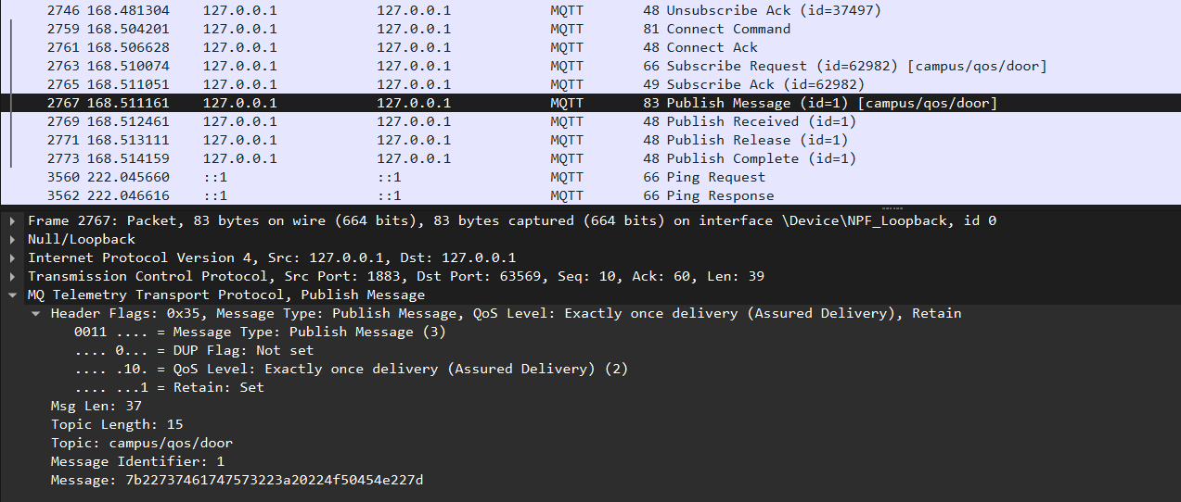
Figure 16 : Latest Status
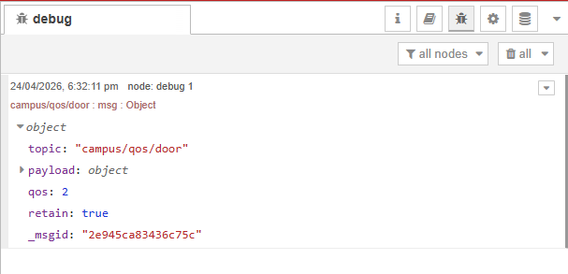
Figure 17: Debug

Discussion
- You observed that QoS 0 requires 1 packet, QoS 1 requires 2 packets, and QoS 2 requires 4 packets. If you are designing a battery-powered ESP32 temperature sensor that updates every 10 seconds, which QoS level would you choose and why? What are the mathematical consequences on battery life and bandwidth if you incorrectly select QoS 2 for this scenario?

For a battery-powered ESP32 temperature sensor that updates every 10 seconds, QoS 0 is the best choice because it only requires one packet per message, minimizing power and bandwidth usage, and occasional data loss is acceptable since a new reading arrives quickly. Mathematically, the sensor sends 6 messages per minute (60 ÷ 10), so QoS 0 uses 6 packets per minute, while QoS 2 uses 24 packets per minute (4 packets per message), which is 4× more traffic; this directly increases Wi-Fi transmission time and energy consumption, meaning the battery could drain significantly faster (e.g., communication lifetime dropping from around 40 hours to about 10 hours), making QoS 2 inefficient and unnecessary for this scenario.

- Explain the fundamental difference between standard MQTT message delivery and a Retained message. Give a real-world Industrial IoT (IIoT) scenario where a Retained message is mandatory for system safety when a new client connects to the broker.

The fundamental difference is that standard MQTT messages are only delivered to clients that are connected at the time of publishing, while a Retained message is stored by the broker and automatically sent to any new subscriber when they connect, ensuring they immediately receive the latest state. In an Industrial IoT scenario such as a factory gas monitoring system, a retained message is critical for safety because if a gas sensor publishes a “DANGER” status with the retain flag, any newly connected monitoring system or alarm controller will instantly know the hazardous condition, instead of waiting for the next update and potentially missing a critical warning.

